EXERCISE 2
cd ~/GitDemo
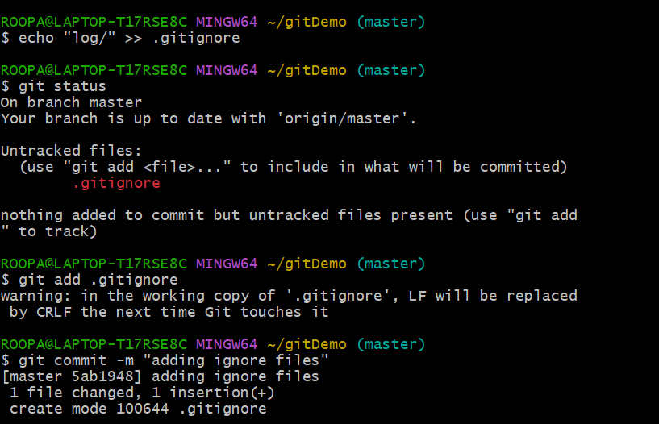
Create test files and folder to ignore
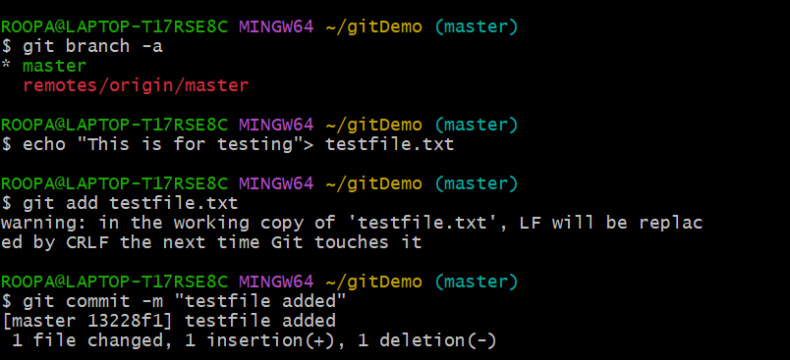
Create a .gitignore file
- Touch .gitignore
  - echo "*.log" >> .gitignore
  - echo "log/" >> .gitignore
  - *.log
  - log/

Check git status
Git status
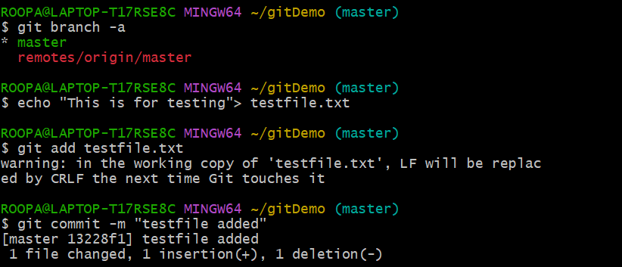

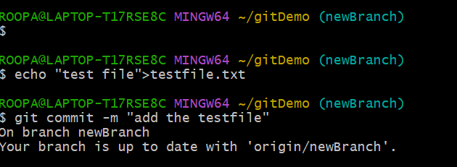

Add and commit only .gitignore
